SWE20001 – Development Project 1: Tools and Practices

Pass Task <5.1>

Duy Phuong Nguyen (101204984)

Lab: Friday 2:30pm

Tutor: Huai Liu

Team number: 3

Henry Tran 102075482

Edward Knight 102700043

Duy Phuong Nguyen 101204984

Christian Ilott 102169762

This report summarizes my contributions to the teamwork in Week <5> as well as the tasks I have performed during this week:

## Task decision:

There are 6 parts in total for this week meeting, so we split the works for 3 members. I got 1 task this week, which is the hardest one because it’s converting VB code to C# code.

* (D2) Who will convert the VB code and fix the compile errors with C# code? This can be shared by several team members.

## Converting CB code to C#

* I use the convert tool which was research by Edward last week. This is the link to our wiki page[: https://github.com/mngduyphuong/battleship-lab03/wiki/8.-Code-conversion-Tools](:%20https:/github.com/mngduyphuong/battleship-lab03/wiki/8.-Code-conversion-Tools)

With just a click, I can convert CB code into C#.

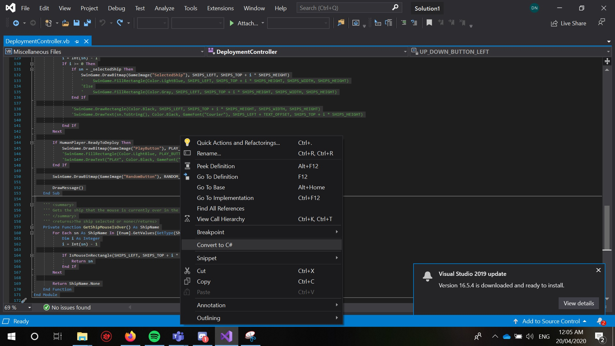

* However, there are many errors after converting process because the tool is not 100% correct.

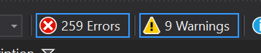

* With the knowledge in C# from last year unit. I tried to fix the project code by myself, so the errors are reduced to 61.



* I can’t fix everything, so I followed the example code in week 6 and use it as a guide.

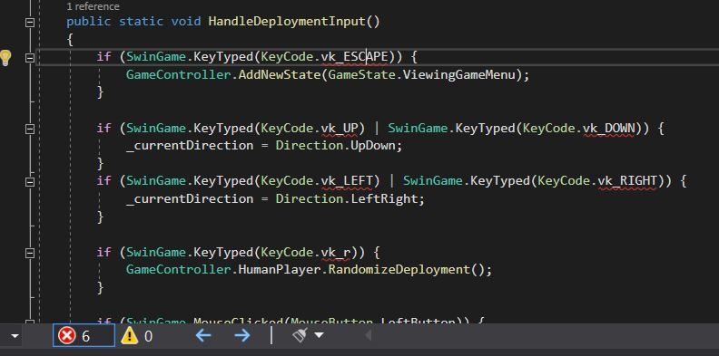

* The total number of errors are reduced to 6 after several tries.

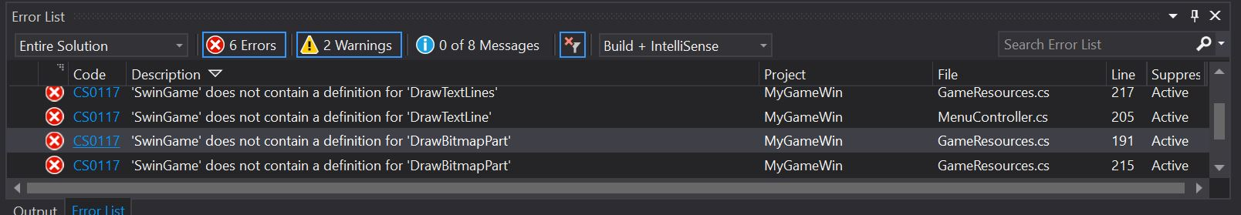

* However, the Swingame library is missing some method, such as: DrawTextLine, DrawBitMapPart, etc and I can’t fix that.



* The remaining files that required fixing is:
  + EndingGameController.cs
  + GameResources.cs
  + MenuController.cs

**GitHub URL:** [**https://github.com/mngduyphuong/battleship-lab03**](https://github.com/mngduyphuong/battleship-lab03)